ML Essential Bootcamp - Shared Notes

[Share link](https://docs.google.com/document/d/1B9qrp-gx8rlhwq4nqAXJYLPJnZhHjXUxkbPIFPhrNjI/edit?usp=sharing)

# Instructor

**Sujee Maniyam**

[bio](https://drive.google.com/file/d/1ATBoDfsJAv_MSPN5n0QEpKpnvSTatiA_/view?usp=sharing)

[sujee@elephantscale.com](mailto:sujee@elephantscale.com)

<https://www.linkedin.com/in/sujeemaniyam>

**Support**

[teamnesto@triveratech.com](mailto:teamnesto@triveratech.com)

# Course Materials

[Course outline](https://drive.google.com/file/d/1HW1djim-3n2xJuL7oo8P76_XeX_wYSGw/view?usp=sharing)

[Shared folder](https://drive.google.com/drive/folders/17wzE5IJW8zy0F9blQNJexxip1FIVf8kF) - has all the assets (go here and download the entire folder as zip)

Slides

Emailed out ???

* [Day 1](https://drive.google.com/file/d/1P4Jw9m3ZahQFDoDjYQL2CuWrK3PMGYO-/view?usp=sharing)
* [Day 2](https://drive.google.com/file/d/1u2yTIZVz_vkhT6xzcp1jtX8tEUlU_aR4/view?usp=sharing)
* [Day 3](https://drive.google.com/file/d/1ee_PQvo-3J-S1aAuuoAtqnZgt3Be88R-/view?usp=sharing)
* [Day 4](https://drive.google.com/file/d/1SRw0lDmAWMgyvSZGaAMft2iL1XJ_PWw_/view?usp=sharing)
* [Day 5](https://drive.google.com/file/d/1wvNojes1S_CbddBWxMCXpMmd7GAZMAUI/view?usp=sharing)

**Labs**

<https://github.com/fenago/machine-learning-essentials-module1>

git clone https://github.com/fenago/machine-learning-essentials-module1

**Lab environment**

Provided, see below

[Scratch pad](https://etherpad.wikimedia.org/p/ml-foundations-1) - for sharing code ..etc

[More resources](https://docs.google.com/document/d/1X5LeVOWW0Z-hgQU-3ztvJ1pVIWM7Gm96gYehvvcRg64/edit#)

Cool demos

* <https://github.com/elephantscale/cool-demos>

# Setting Expectations

Discuss course objectives.

# Day-wise Logistics

**Day 1 - Sept 27 - Monday**

Background survey : <https://www.surveymonkey.com/r/TDGQJ79>

**Day 3/4 - Mid course checkin**

https://www.surveymonkey.com/r/ChkIn-Gen-2021

# Teams & Lab Assignment

Lab url : http://jpmc-mlX.eastus.azurecontainer.io/

Replace X with your number below.

Password : 1234

Blue team and Green team

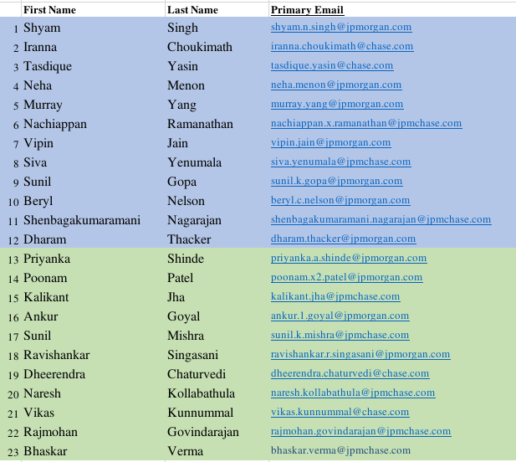

# Lab Environments

**\*\*Option-1 : Provided above. This is what we will use for the class.**

Option-2: <https://mybinder.org/> - free. Online

Option 3 : [Google colab](https://colab.research.google.com/)

**\*\*Option 4: setup your own machine too. We will provide instructions**

# Day 1

[Day 1 notes](https://docs.google.com/document/d/1hpboVEC5rDtOjrKSjGQCkxtYWVx_b2zcneE4NomTsdE/edit)

# Day 2

[Day 2 notes](https://docs.google.com/document/d/1-Vgt3qDScVHR_K5TuHWgnrx7yvtqkTA4Wl-M1WpKzyI/edit#)

# Day 3

[Day 3 notes](https://docs.google.com/document/d/177xJ1dDKLPaO-ffxgvu2cLlRd4i6AKhp-5kkVhYWGSU/edit#heading=h.jbt2w5f1xkdf)

# Day 4

[Day 4 notes](https://docs.google.com/document/d/1ZtX2aPDBWZUwGZSRsbljUlLdL1mhuOHhlSrfAQQn8M0/edit#)

# Day 5

[Day 5 notes](https://docs.google.com/document/d/1TYBD5v2o-Wy9K2nBTMsc9YQH-gigNc1_9OKSBBfcI4Y/edit#)

# Cool-Demos

Check each day notes

[Pushups](https://giphy.com/gifs/viceworldofsports-viceland-vice-world-of-sports-3oKIPhonWVy71uXjxe)

[Amazing goal](https://giphy.com/gifs/kvkofficieel-kv-kortrijk-amazing-goal-dalibor-veselinovic-lffUbdb0YmwqvzrnyK/fullscreen)

[bootcamp](https://giphy.com/gifs/americangrit-crossfit-american-grit-l0K4cJKbYstWm5qCI)